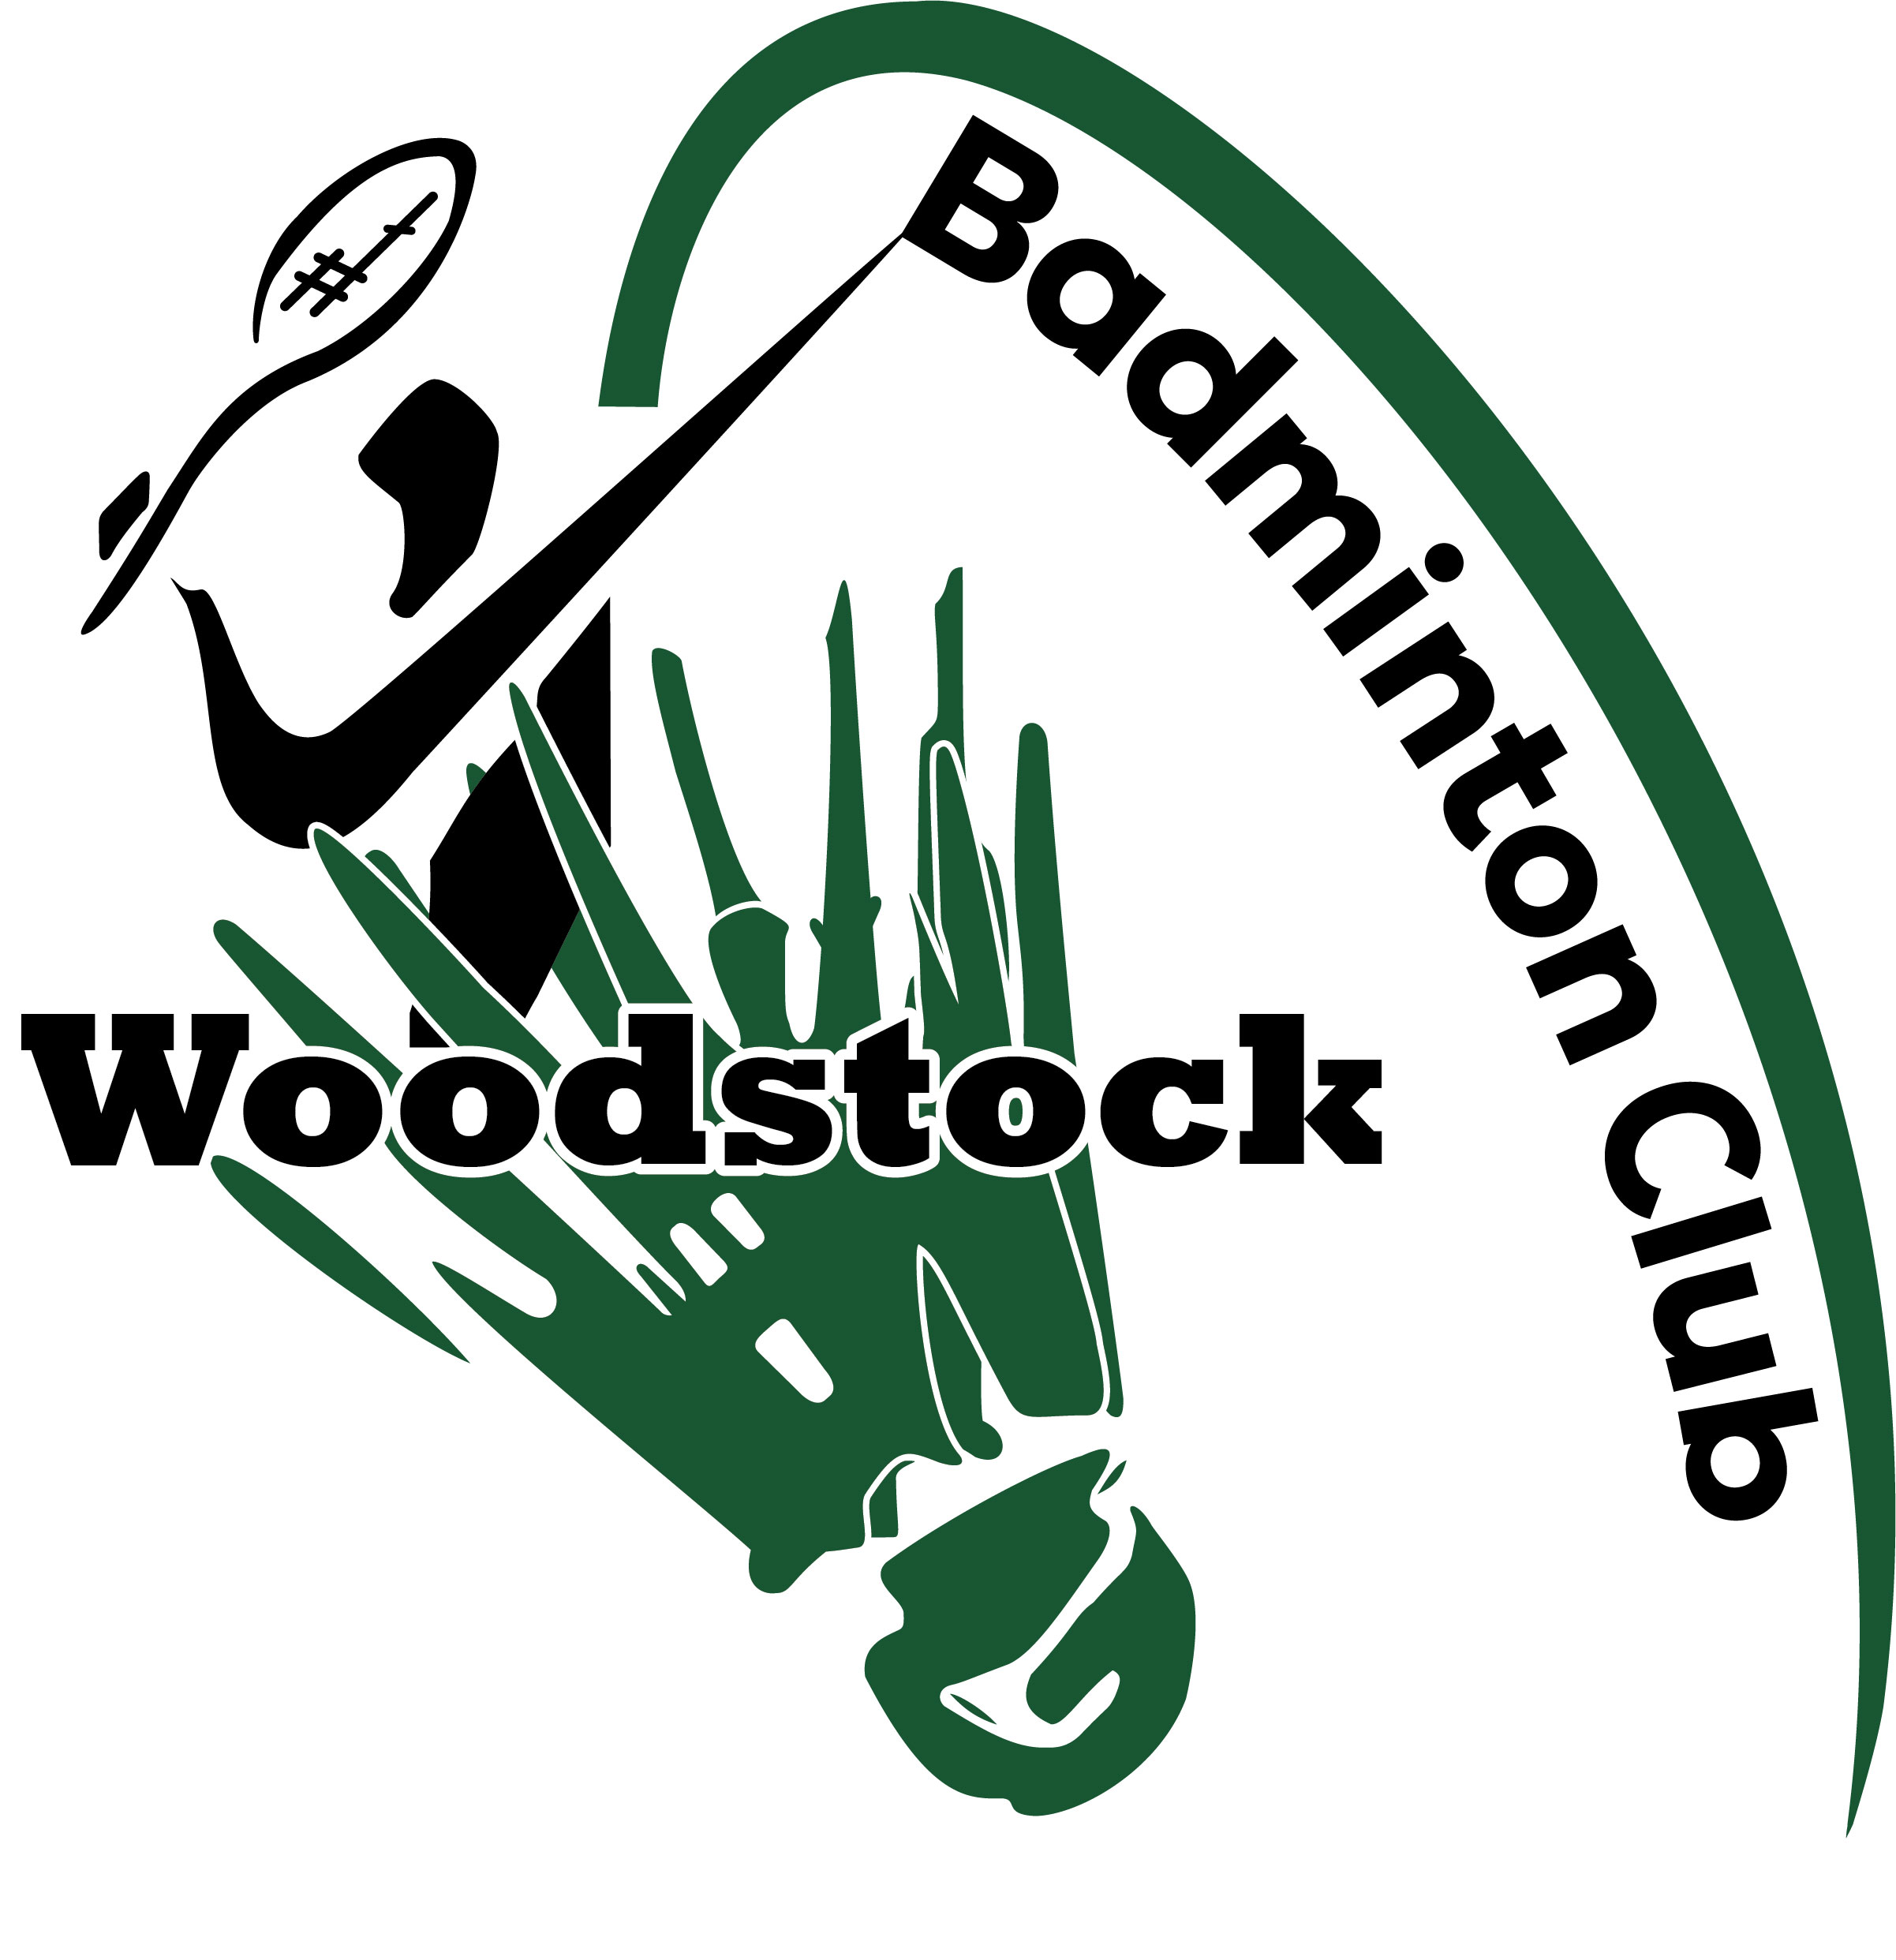

WOODSTOCK MASTERS BADMINTON TOURNAMENT

FRIDAY, December 7, 2018 – Sunday, December 9, 2018

Locally organized and run by members of the Woodstock Badminton Club.

Where: Woodstock Badminton Club, 310 Hunter St., Woodstock, Ontario N4S 4E9
Phone: (519) 539 – 1191

Eligibility: Your age as of the Canadian Masters Championships in April, 2019.

Events: FRIDAY, December 7, 2018 @ 7:00p.m.: SINGLES – Men / Women
Age Categories – 35+,40, 45, 50, 55, 60, 65 and 70. Convener reserves the right to combine age categories depending on number of entries received. Singles will be completed on Friday night.

SATURDAY, December 8, 2018 @ 9:00a.m.: DOUBLES – Men
Age Categories – 35+, 40, 45, 50, 55, 60, 65 and 70. Convener reserves the right to combine age categories depending on number of entries received. Doubles will be completed on Saturday. To encourage more 35+ teams to enter, there will be a guarantee of at least 3 matches in that age category, if there are at least FOUR (4) teams. All other age categories will have a main round with a consolation round or a round robin, depending on numbers.

SATURDAY, December 8, 2018 @ 12:00 p.m.: DOUBLES – Women
Age Categories – 35+, 40, 45, 50, 55, 60, 65 and 70. Convener reserves the right to combine age categories depending on number of entries received. Doubles will be completed on Saturday. To encourage more 35+ teams to enter, there will be a guarantee of at least 3 matches in that age category, if there are at least FOUR (4) teams. All other age categories will have a main round and a consolation round or a round robin, depending on numbers.

SUNDAY, December 9, 2018 @ 9:00a.m.: MIXED DOUBLES
Age Categories – 35+, 40, 45, 50, 55, 60, 65 and 70. Convener reserves the right to combine age categories depending on number of entries received. Mixed Doubles will be completed on Sunday. To encourage more 35+ teams to enter, there will be a guarantee of at least 3 matches in that age category, if there are at least FOUR (4) teams. All other age categories will have a main round and a consolation round or a round robin, depending on numbers.
ENTRY FEE: $35.00 for the first event and $5.00 for each additional event. May play 5 events total, with no more than 2 events in each discipline ( men’s singles, women’s singles, men’s doubles, women’s doubles and mixed doubles ). There will be prizes for main round champions and runner ups and the consolation round champions. Round Robin events will have prizes for champions and runners up.

POT LUCK: The W.B.C. began a tradition of having a pot luck dinner on the Saturday. If you wish to participate please bring something to share with your hungry competitors to begin sometime in the late afternoon as we finish up play for the day. If with your entry you wish to let me know what you would like to bring for the Potluck that would be great or just bring whatever you wish or bring nothing at all.

DEADLINE: Entries must be received by THURSDAY, December 6, 2018 @ 8:00P.M.
You may e-mail entries to: whbrennan@rogers.com
(Please include phone number in e-mail in case I need to contact you).
You may phone Bill Brennan at: 1(519) 759-5638
You may phone the W.B.C. at: 1(519) 539-1191
Payment is at the door.

www.woodstockbadmintonclub.org

EVENTS: Singles____________________ Age Group_________________________
Singles____________________ Age Group_________________________
Doubles Partner / Doubles Partner Requested__________________________
Age Group__________
Doubles Partner / Doubles Partner Requested__________________________
Age Group__________
Mixed Doubles Partner / Mixed Doubles Partner Requested________________
Age Group__________
Mixed Doubles Partner / Mixed Doubles Partner Requested________________
Age Group__________
*** REMEMBER ONLY 5 EVENTS IN TOTAL, NO MORE THAN 2 IN ANY ONE DISCIPLINE***

www.woodstockbadmintonclub.org

